YEAR 7 SCIENCE
INVESTIGATION - LEVERS

AIM: To determine what effect increasing the effort arm of a lever has on lifting a load.

MATERIALS: 1 x metre rule 1 x 2 N spring balance
4 x 50 g masses 1 x 5 N spring balance
1 x fulcrum (cork, pencil) 1 x loop of string

METHOD: 1. Set up the following lever.

spring balance
200 g load
30 cm mark
60 cm mark

2. Place a 200g load at the 0 cm end of the rule.

3. Pivot the ruler at the 30 cm mark.

4. Connect a 2N spring balance at the 60 cm mark with a loop of string.

5. Pull down with the spring balance until the rule is horizontal (balanced). Record the force in Newtons.

6. Repeat measurements of the force at the following marks: 70 cm,
80 cm, 90 cm and 100 cm.

RESULTS:

Distance mark on rule (cm) | Effort arm - distance from fulcrum (cm) | Force (N)
60 | 30
70 | 40
80 | 50
90 | 60
100 | 70

GRAPH: Do a line graph on the next page to show your results.

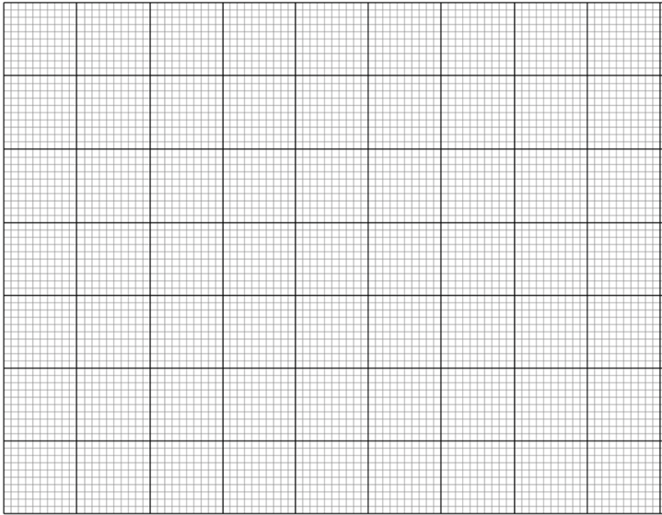

CONCLUSION: What is the effect of increasing the effort arm?

